Group 2

**Blackjack**

Software Design Document

Name (s):

Andy Cheong

Aparna Gangwar

Mohak Garg

Niranjan Akolkar

Date: (03/20/2019)

Table of Content

**Introduction** **2**

Purpose 2

Scope 2

Overview 2

Game Rules 3

**Software Requirements** **4**

Functional Requirements 4

Non Functional Requirements 4

**System Architecture** **6**

Class Diagram 6

Use Cases 8

Sequence Diagram 10

**Glossary of Terms** **11**

**Component Design** **12**

Back-End Objects 12

Front-End Classes 13

**Human Interface Design** **15**

Overview of User Interface 15

Screen Images 16

Screen Objects and Actions 18

**Requirements Matrix** **21**

**Reference** **25**

List of Figures

Back-End Class Diagram 8

Front-End Class Diagram 9

Use Case 1 10

Use Case 2 11

Sequence Diagram for Use Case Hit 12

Start Game Screen 18

Game Rules on Clicking the “Rules” Button 18

Clicking “Start Game” Button 19

Proceeding After Entering Player’s Name 19

After Pressing Deal 20

End Game Screen 20

List of Tables

Blackjack Functional Requirements 6

Initialize Game 23

Blackjack 24

Stand 24

Hit 24

Double 25

Surrender 25

Bust 26

## Introduction

### Purpose

This software design document describes the architecture and system design of Blackjack game for a player to play against the dealer(computer).

### Scope

Blackjack is a modification of the game Twenty-One and is intended to be a card game that allows users to play the game against the computer on an elegant interface. The project has been implemented for fulfillment of requirements for COEN 275- Object Oriented Analysis, Design and Programming.

### Overview

This document will give a brief overview of the game, the requirements, design decisions taken to fulfill the functional and the non-functional requirements; and the components used for the development.

Section 1 is the high level introduction to the project.

Section 2 gives the functional and the non functional requirements we began with.

Section 3 talks on a high level about the system architecture and how various various pieces of the software will interact with the end-user; with the aid of class diagrams, use cases and the sequence diagrams.

Section 4, Glossary of Terms, defines the terms and what they mean throughout the system.

Section 5, Component Design, talks in-depth about all the components of the backend and the frontend, their functionalities and how they interact with each other to form a functional software.

Section 6, Human Interface Design, talks about the User Experience, which was one of our most crucial non-functional requirements while building a game.

Section 7 talks about the requirements matrix and maps our initial requirements with the different phases of software development. This sections contains all of our traceability matrices that helped us check our progress throughout the development process.

The final section is the references that helped us throughout building of the software.

### Game Rules

* Aces may be counted as 1 or 11.
* Number cards hold their value.
* Face cards have a value of 10.
* After the players have bet, the dealer will give two cards to each player and two cards to himself. One of the dealer cards is dealt face up. The facedown card is called the "hole card."
* The following are the choices available to the player:
* Blackjack: Player is deal a hand of value 21 (Ace + 10 value card). Wins
* Stand: Player ends his turn
* Hit: Player draws another card.
* Bust: Player hand value exceed 21, loses
* Double: Player doubles his bet.
* Surrender: The player forfeits half his wager, keeping the other half. Game ends
* After player has had his turn. If dealer hand equals player hand and value is less than 18. Dealer will draw a card..
* If the dealer goes over 21 points, then any player who didn't already bust will win.

## Software Requirements

### Functional Requirements

|  |  |  |
| --- | --- | --- |
| **Req. ID** | **Title** | **Description** |
| FR-001 | Registration and set bet | Player should be able to to enter his name and choose the bet amount to start the game |
| FR-002 | Deal Cards | Player should be able to get 2 random cards as soon as the game starts |
| FR-003 | Hit | Player should be able to add a new card to his current set of cards |
| FR-006 | Stand | Player should be able to stand pat with his cards |
| FR-007 | Double Down | Player should be able to double the bet amount after the start of the game |
| FR-008 | Surrender | Player should be able let go of the cards after the initial deal of cards and lose half of the bet amount |
| FR-009 | Balance | Player should be able to see the total balance he has during the game |

**Table 2.1.1 - Blackjack Functional Requirements**

### Non Functional Requirements

PFR-001

The game should start immediately after the program is executed from the system.

PFR-002

The game should not crash when the player is within the game.

PFR-003

The user interface should be simple yet intuitive.

PFR-004

The user should be able to figure out his way through the game play on his own.

## System Architecture

The system architecture is broken down into two sections (Back-End and Front-End Class diagram). The purpose of this separation is to show independence between the back-end and the front-end components of the software. Each class diagram gives a high level view of the design of the software.

### Class Diagram

* + 1. **Back-End Class Diagram**

The Back-End Class Diagram shows how each class/object is connected to each other. This also gives a view on how to get data from each other. In each class the types and functions are shown so that anyone can see what the class does.Separation of concerns, stable intermediate forms, relative primitives, encapsulation, modularity, hierarchy are some of the principles that can be extracted from this class diagram. The back-end code does all the calculations and functionality related to the rules of the game.

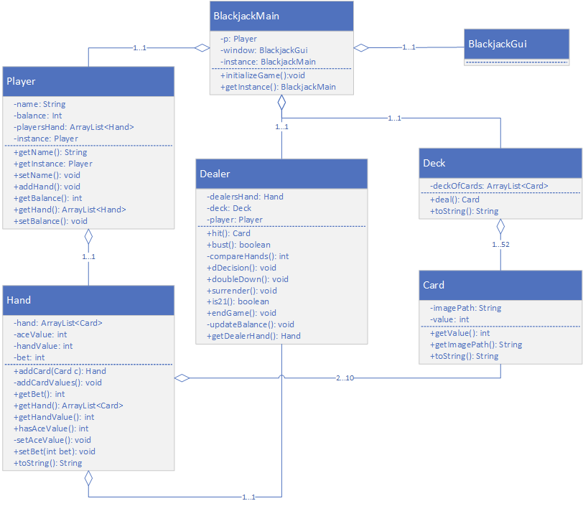

**Figure 3.1.1 - Back-End Class Diagram**

Figure 3.1.1 displays the back-end class diagram. It is important to notice that the object BlackjackGui does not have any functions. That is because BlackjackGui is a front-end class. It is shown in this class diagram to give the reader an understanding of where the back-end and front-end connect.

* + 1. **Front-End Class Diagram**

The Front-End Class Diagram, similar to the back-end class diagram shows how each class/object is connected to each other. This also gives a view on how to get data from each other. In each class the types and functions are shown so that anyone can see what the class does. Singleton pattern, inheritance, abstraction, encapsulation, and modularity are some of the principles that can be extracted from this class diagram. The front-end code contains all the functionality related to the GUI.

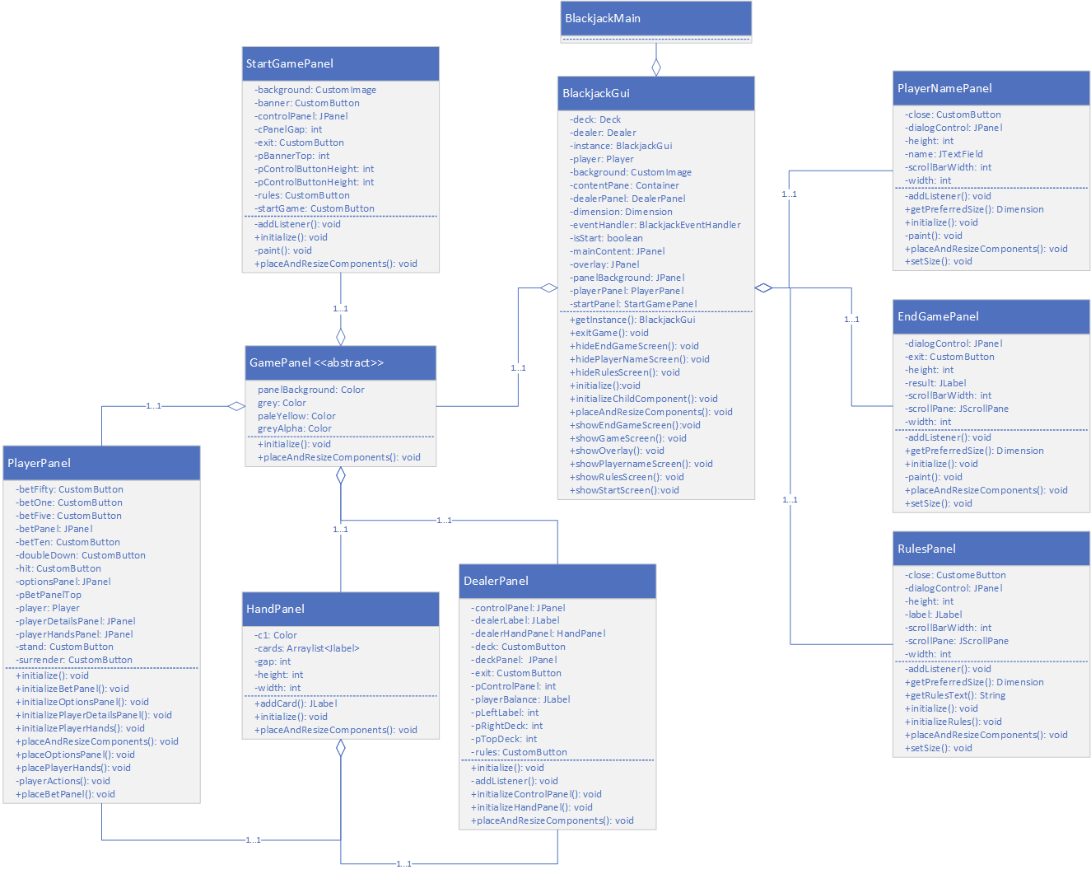

**3.1.2 - Front-End Class Diagram**

Figure 3.1.2 displays the back-end class diagram. It is important to notice that the object BlackjackMain does not have any functions. That is because BlackjackMain is a back-end class. It is shown in this class diagram to give the reader an understanding of where the back-end and front-end connect.

The next section will go over some use cases. Using the class diagram, one will be able to understand how the code should flow. This will help the developer understand which functions need to be considered when developing the code.

### Use Cases

This section will describe some use cases that a user is able to perform with the software. Use cases give developers information of the behavior of a user so they can understand the needs of a user and step in their shoes to empathize with them. This allows developers to keep users in mind when they develop the product.

* + 1. **Use Case 1 - HIT**

The HIT use case is the main interaction that the user would do using the software. HIT functionality is to draw a card and add it to the hand. The figure below shows a use case diagram depicting the interaction a user would have with the software once they use the HIT functionality.

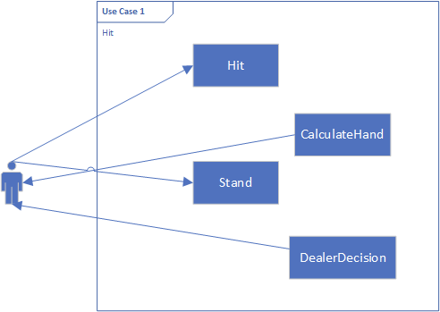

**Figure 3.2.1 - Use Case 1**

Figure 3.2.1 represents the use case diagram for functionality HIT. The user would select the HIT button to draw a new card. While the user gets a new card, CalculateHand will determine their new hand value. Then the user can decide if they want to HIT again or select STAND. Once STAND is selected the user ends their turn and the dealer will perform its action with the DealerDecision. DealerDecision will then return whether the player won or lost.

* + 1. **Use Case 2 - Options**

The Options use case shows the other interactions the user can have while playing a blackjack game. Once the game is started the user is able to select from the options HIT, STAND, SURRENDER or DOUBLEDOWN. The SURRENDER and DOUBLEDOWN option can only be used once.

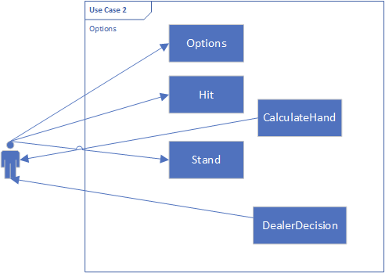

**Figure 3.2.2 - Use Case 2**

Figure 3.2.2 represents the use case diagram for the Options use case. The user would select an option to either double their bet or lose half their bet. Once they select an option the game will proceed based on the rules. If the user selected DOUBLEDOWN option, the user will then select HIT and add a new card to the hand. CalculateHand will determine their new hand value. Then the user can decide if they want to HIT again or select STAND. Once STAND is selected the user ends their turn and the dealer will perform its action with the DealerDecision. DealerDecision will then return whether the player won or lost.

### Sequence Diagram

The following represents the flow of the game when the player presses the hit button and one more card is dealt to him from the deck of existing cards. The game begins as the player selects the bet amount and the initial two cards are dealt to both the player and the dealer. Dealer checks for a blackjack, if it isn't then the game continues and player presses hit.

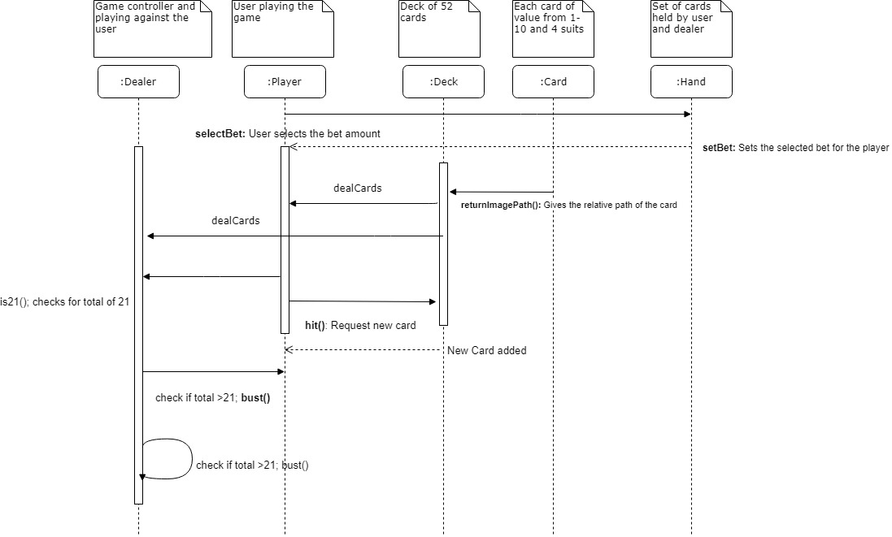

**Figure 3.3.1 - Sequence diagram for Use Case Hit**

## Glossary of Terms

The following are terms that are used in the game of blackjack. This list will give the reader a clear understanding of what each term means. Once the terms are understood then everyone working on the project will have the same understanding of the terms.

* **Blackjack**: When a player is deal 2 cards at the beginning of the game with a combined value of 21. It will be an Ace + 10 or face card. Player automatically wins.
* **Stand**: Player ends his turn
* **Hit**: Player or dealer draws another card.
* **Bust**: Player or dealer hand value exceed 21, loses
* **Double**: Player doubles his bet. Can only be done before Hit.
* **Surrender**: The player forfeits half his wager, keeping the other half. Game ends. Can only be done before Hit.
* **Deal**: dealer deals two cards to the player and two cards to himself.
* **Face card**: jack, queen, king.
* **Ace card**: can be valued at 1 or 11 depending on situation
* **Dealer**: the computer that the user is playing against.
* **Bet**: risk a sum of money, against the dealer on the basis of the outcome of a future event, in this case your hand value being greater than the dealer’s hand.

## Component Design

In this section, we list out all the classes and its member functions which gives the functionality to the Blackjack game. We divided the classes into two parts, one for the backend and the other for the frontend which controls the GUI part of the blackjack game.

### Back-End Objects

* **BlackjackMain:-** Class which initializes the backend functionality of the game
  + **initializeGame():** Initializes the backend of the game
  + **getInstance():** This method is used to create a single instance of the BlackjackMain class
* **Player:-** User class which plays the game against the system
  + **addHand():** Adds a new hand for a player
  + **getHand():** Returns the player hand
  + **getInstance():** This method is used to create a single instance of the Player class
* **Hand:-** Class which holds the cards for the player and the dealer
  + **addCard():** Adds a new card to the players existing card
  + **addCardValues():** Calculates the total hand value when a new card is added to the hand
  + **setBet():** Sets the selected bet for the player
  + **setAceValue():** Keeps the count for the number of aces in the hand
* **Dealer:-** Class which acts like game controller of the system
  + **hit():** Picks a random card from the deck and adds it to the hand
  + **bust():** Checks if the existing hand is over 21 or not
  + **compareHands():** Compares the existing hand values for both the player and dealer and guides the dealer for its further moves
  + **dDecision():** Game controller for the dealer which decides further moves based on the values returned by compareHands()
  + **doubleDown():** Doubles the bet for the player
  + **surrender():** Ends the game for the player and returns half of the bet amount
  + **is21():** Checks if the hand value for both the dealer and player for a total of 21
  + **endGame():** Displays the result of the game and ends it
  + **updateBalance():** Based on the result of the game, updates the available balance for the player
* **Deck:-** Class which creates and holds a deck of 52 cards
  + **deal()**: Selects and removes a random card from the deck
* **Card:-** Class which creates a card having value and image path.
  + **getImagePath():** Returns the image path for the card
  + **getValue():** Returns the card value

### Front-End Classes

* **BlackjackGui:-** Class which initializes front end functionality.
  + **initializeChildComponents():** Initializes the dealer and the player panel
  + **showStartScreen():** Initializes the start panel
  + **showGameScreen():** Initializes the game panel
  + **showRulesScreen():** Displays the rules of the game
  + **exitGame():** Exits the game
  + **placeAndResizeComponents():** Resizes the components and set the location when new ones are added to the player and dealer panel
* **GamePanel:-** It is an abstract class inherited by other classes which show similar behaviours
  + **initialize():** Abstract method
  + **placeAndResizeComponents():** Abstract method
* **StartGamePanel:-**
  + **addListener():** Adds the functionality to the start game rules and exit buttons
  + **initialize():** Initializes the game panel
* **PlayerPanel:-** Extends the GamePanel class and initializes the components for the player panel class
  + **initializePlayerDetailsPanel():** Initializes the player details
  + **initializeBetPanel():** Initializes the bet buttons
  + **initializePlayerHand():** Initializes the player hand panel
  + **initializeOptionPanel():** Initializes the hit, stand, deal, surrender and doubleDown buttons
  + **playerActions(Hand hand):** Adds the functionality to all the buttons in the player panel
* **HandPanel:-** Holds the cards for both the dealer and player in their respective panels
  + **addCard():** Adds the card to the hand panel
* **DealerPanel:-**
  + **initialize():** Initializes the whole dealer panel
  + **initializeHandPanel():** Initializes hand panel object for the dealer
  + **addListener():** Adds the functionality to the rules and exit buttons in the dealer panel
* **PlayerNamePanel:-** Sets the player name at start of the game
  + **initialize():** Initializes the dialog box for the player to enter the name

## Human Interface Design

This section talks about how the user interacts with the system. Sub section 6.1 gives a high level view of the software from the user’s perspective. It mentions the screens and the options available to the users. Sub section 6.2 shows the screenshots of the possible screen states throughout the flow of the game, in a sequential manner. It can be used as a guide of how to proceed through the game. Sub section 6.3 talks about the various components on the screen in detail and how will they behave when the user interacts with them.

### Overview of User Interface

The UI has two different screens and three dialog boxes with an overlay on the base screen. The first screen is the start game screen, which gives the user options to enter the main game screen, go through the rules or exit the game.

The main game screen appears after the user has clicked on “Start Game” and entered their name on the dialog box that appears next. Game Screen has poker chip like buttons where the user can place the bets, it has the buttons through which the player can execute the game play and also shows the basic information like player’s name(above the cards), his current hand value(above the cards), total balance through multiple gameplays(Top Left corner) and the current bet(below the bet buttons). On the top right corner, the player has navigation options to exit the game or to see the rules again.  
  
When the game ends, either the player busts or stands, the end game screen is shown, which tells the user if he has won or lost and how much amount will get added or deposited to his total balance. Here, the player can either exit the game by clicking the close button on the frame, or can choose to stay and keep playing the game.

### Screen Images

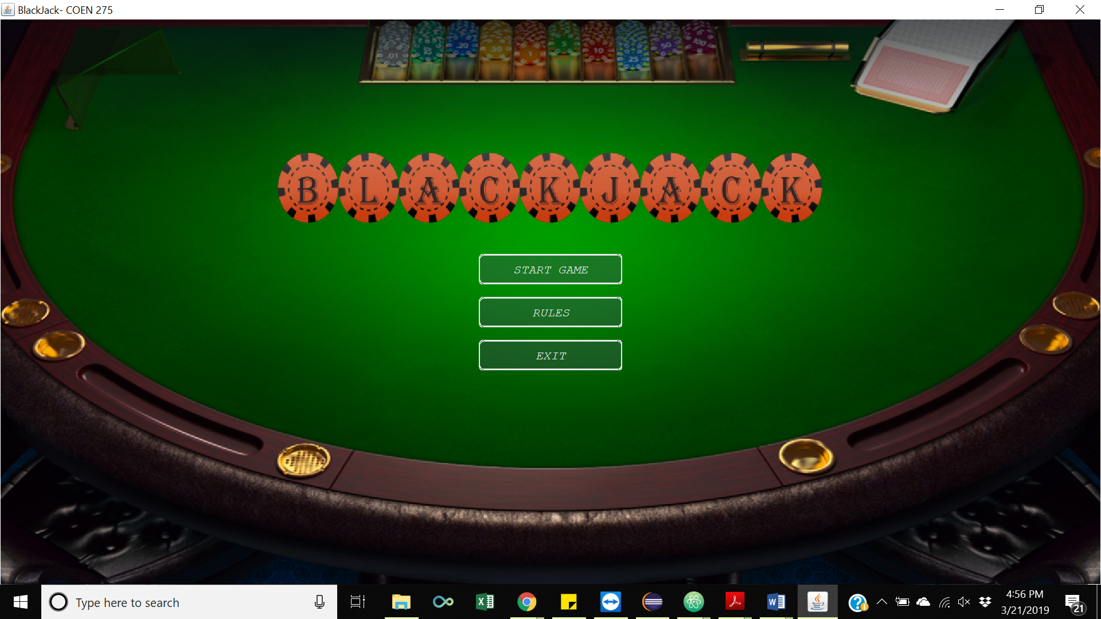

**Figure 6.2.1 - Start Game Screen**

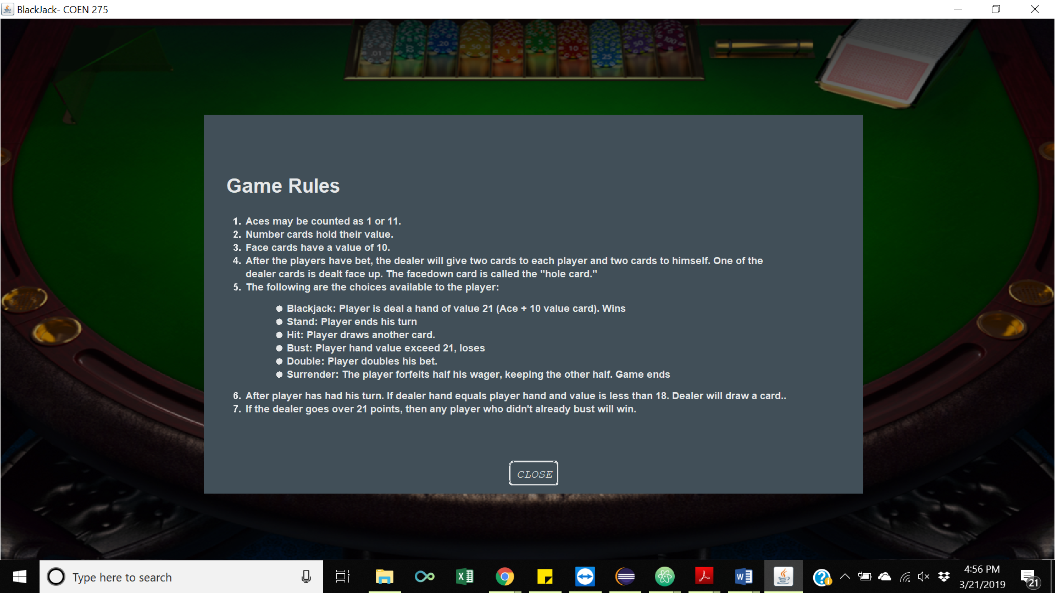

**Figure 6.2.2 - Game rules on clicking the “Rules” Button**

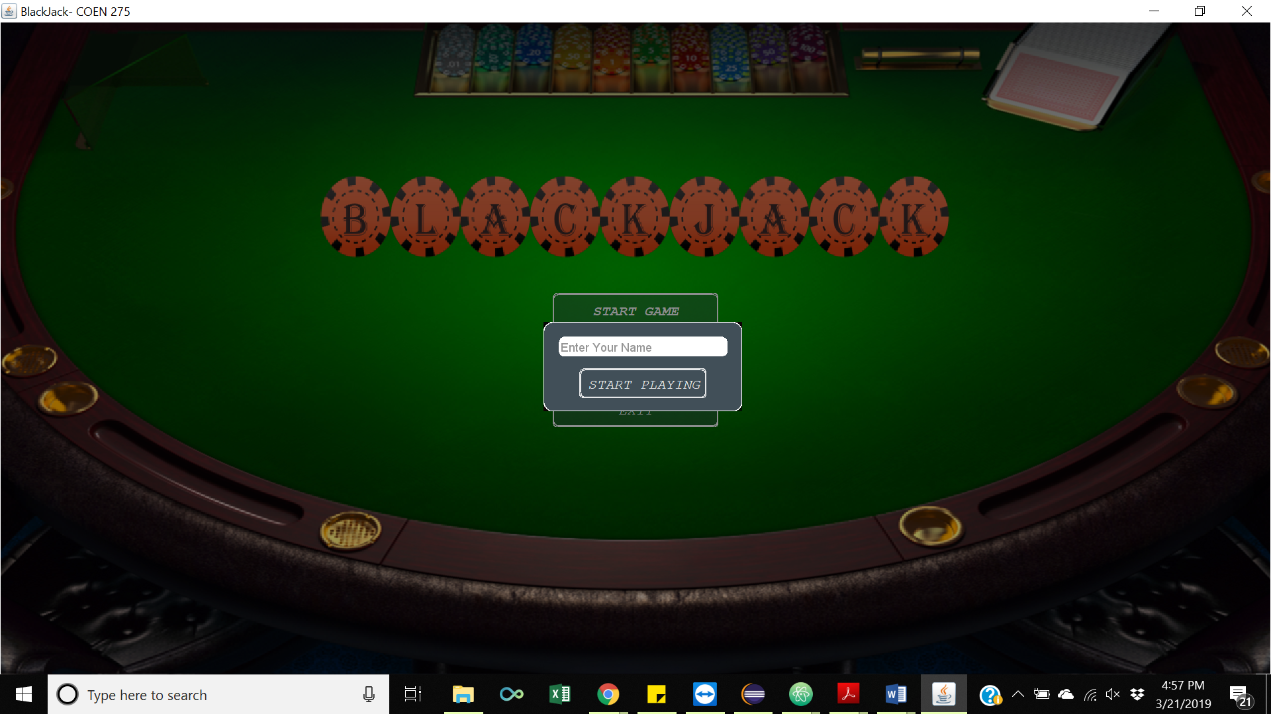

**Figure 6.2.3 - Clicking “Start Game” Button**

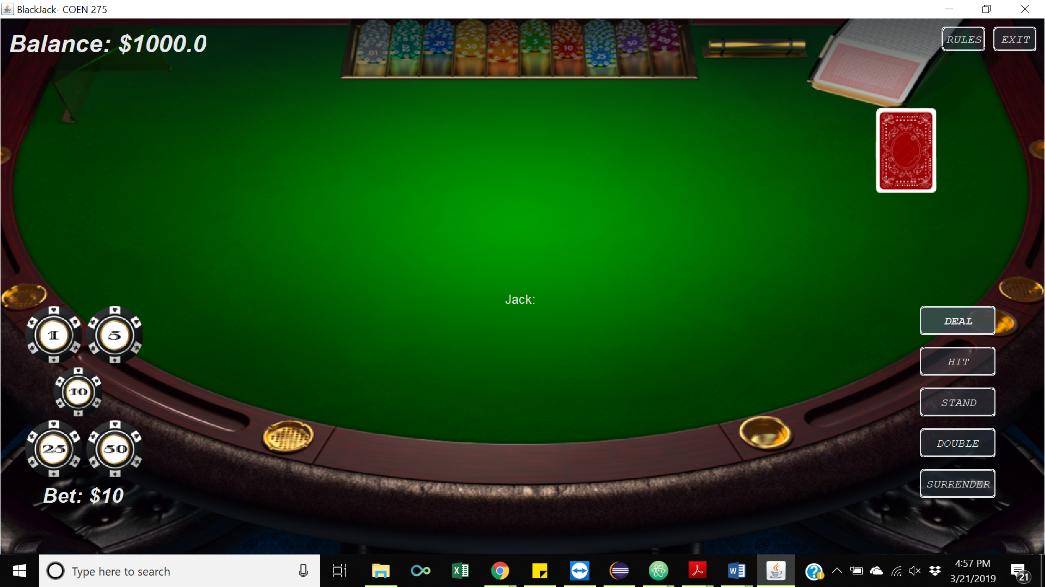

**Figure 6.2.4 - Proceeding After Entering Player’s Name**

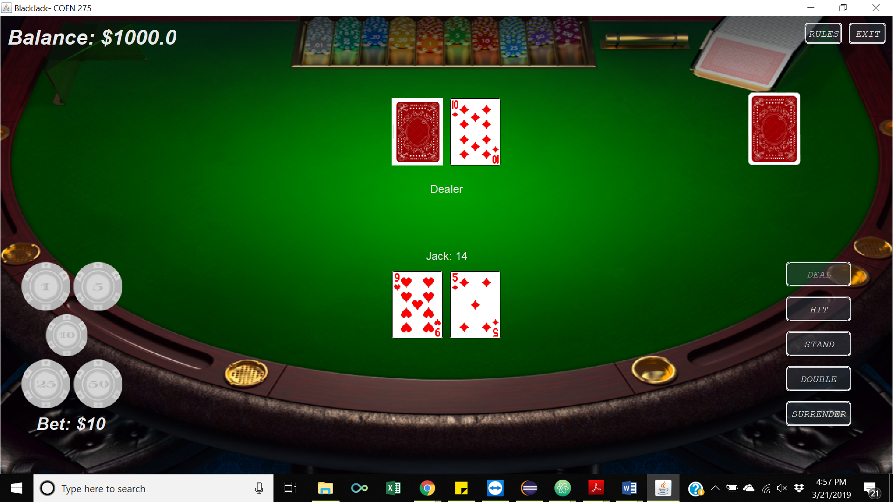

**Figure 6.2.5 - After Pressing Deal**

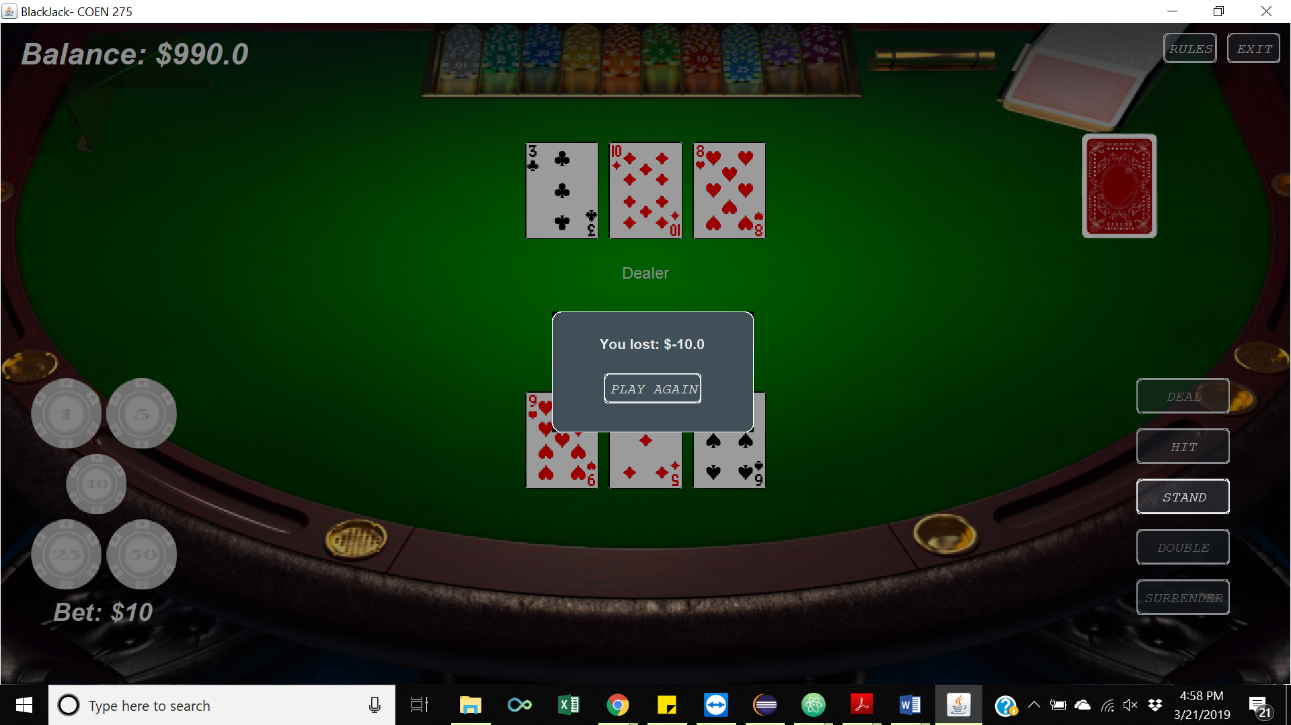

**Figure 6.2.6 - End Game Screen**

### Screen Objects and Actions

With the start of the game, the user sees the start screen which gives him an option to go through the rules through the “rules” button, start playing the game through the “Start Game” button or simply exit the game, in case he has changed his mind.

On pressing “Rules”, user can see the RulesPanel which is a dialog box that opens up and lists all the game rules. It has a single button that redirects the user back to the Start Game screen.

On pressing “Start Game”, the user can see the startGamePanel. Similar to the rulesPanel, it shows a dialog box where the user can enter his name and click “Start Playing”.

“Start Playing” button redirects the user to the game screen. Game screen is the heart of our software and is made up several components, as listed below:

* Player and Dealer Panel: To be able to have a separation of concerns, we have divided our game screen itself into two panels, player and dealer. The upper half of the screen is the dealer panel and the lower half is the player panel. This also allows us to properly interface these GUI panels with the backend Player and Dealer objects.
* Player Panel Components:
  + Player’s Hand: The hand is displayed somewhere in the middle of the lower half of the screen. Player’s name and hand value are displayed right above it.
  + Placing Bets: In the bottom left of the screen, there are five buttons with bet values of $1, $5, $10, $25 and $50, respectively. Player starts with a minimum bet of $10 and can bet more by clicking on any of the chip. The total bet for the current round is displayed below the bet buttons.
  + Player Actions or Player Decisions: On the bottom right of the screen there are five buttons which denote the actions that a user can take through the game. Each of these buttons covers an option each from the Use case 2 in section 3.2.2.
  + Deal: On clicking hit, random cards are dealt to the player and the dealer. Player can see his hand total alongside his name, just above the cards. At this point, player can only see one of the dealers cards and based on that can further decide on what to do. Also, the bet buttons get disabled as soon as the button is clicked.
  + Double: This option is available only while the player has just pressed the deal. The player can decide if he wants to double his bet or not.
  + Surrender: Similar to double, this option is available only when the player has just pressed deal. It allows the player to surrender and regain half of his bet.
  + Hit: A player can hit to deal one more card and increase the total value of his hand. Hit can be clicked multiple times until a stand is clicked, or the player busts. Once it is clicked, the options Surrender and Double get disabled.
  + Stand: Stand allows a player to stop playing when he is satisfied with his hand value. At this point in the game, the dealer starts hitting until he busts or gets a higher value hand value than the player. The dealers cards are displayed and the end game screen is called.
* Dealer Panel Components:
  + Player Balance: On the top left corner of the screen, we display the player’s balance. Even though it belongs to the player, intuitively, we did not want to over crowd the player panel and still wanted it to be at a place that makes its presence important, yet subtle. Hence, we chose this location for it.
  + Dealer’s Hand: A dealer’s hand is placed in-line (along the vertical axis) with the player’s hand. It is somewhere in the middle of the upper half of the screen. Right below the hand is a static label that says “Dealer”. The label was added just to maintain the consistency in design for the hands of both dealer and player.
  + Deck: In-line (along the horizontal axis) of the dealer’s hand is the deck. The deck is a static label to represent the playing deck of cards.
  + Rules button: On the top right of the screen, we have another “Rules” button, to help guide the player through the game rules in case he needs to see them between the game play. This was placed keeping people new to the game in mind.
  + Exit: To exit the game. It is just a utility button to give more freedom to the player.

EndGame screen is similar to rules and startgame panel and has a dialog box which tells the player the amount that he has won or lost. It gives the player the option to Play again. On clicking the button, the player is redirected to the start game screen but with the same balance. In the backend, the dealer the deck are re-initialized but the player remains the same.

For the rulesPanel, the startGamePanel and the endGamePanel, the overlay is a JPanel with a translucent background that is created in the BlackjackGui class.

# Requirements Matrix

Multiple traceability matrices were created to track the development and testing efforts of the software. Each traceability matrix was derived from the game rules and requirements. Additionally, a description was added to each task so that the owner of the task had a good understanding of what needed to be done. A test function also needed to be created for each task. Once the implementation and test function is completed and tested, the task could be marked as complete. Below you will find 7 traceability matrices that were used to track the progression of the software implementation.

|  |  |  |  |
| --- | --- | --- | --- |
| Initialize Game | | | |
| Requirements | Description | Complete | Test |
| 1.1 Shuffle Deck | Create Deck | Yes | testDeckSize() |
| 1.2 Deal Cards | Deal cards to player or dealer | Yes | testDealCard() |
| 1.3 Create Player | Create player Class | Yes | testInitializePlayer() |
| 1.4 Dealer dealt two cards | Create Dealer Class | Yes | testInitializeDealer() |
| 1.5 Dealer display hand | Dealer shows 1 card only | Yes | testShowCard() |
| 1.6 Player Name | Player enters their name in a text box | Yes | testEnterPlayerName() |
| 1.7 Player bet | Player selects the bet amount | Yes | testBetAmount() |
| 1.8 Start game | Deal two cards to player and dealer | Yes | testDealCards() |

**Table 7.0.1 - Initialize Game**

Table 7.1 shows the traceability matrix for “Initializing Game” requirements. The tasks for this requirement are related to creating the game. Creating the board, player, dealer, deck, card is the first part of initializing a game. Dealing cards, bets, and starting the game was implemented after the different objects were created

|  |  |  |  |
| --- | --- | --- | --- |
| 2 Blackjack | | | |
| Requirements | Description | Complete | Test |
| 2.1 Blackjack win | Check if player won at beginning of game | Yes | testIs21() |
| 2.2 Blackjack bet | Player wins 50% more of the bet | Yes | testBalance() |

**Table 7.0.2 - Blackjack**

Table 7.2 shows the traceability matrix for “Blackjack” requirements. For the “Blackjack” condition to be true, the software has to check if the hand value of the user is 21 after the initial two cards are dealt. If that is true then the user wins 1.5 times the amount of the bet.

|  |  |  |  |
| --- | --- | --- | --- |
| 3 Stand | | | |
| Requirements | Description | Complete | Test |
| 3.1 Stand | Player ends their turn | Yes | testStand() |
| 3.2 Stand | Dealer starts playing | Yes | testdDecision() |

**Table 7.0.3 - Stand**

Table 7.3 shows the traceability matrix for “Stand” requirements. When a player selects “Stand”, they will end their turn and the dealer begins its turn.

|  |  |  |  |
| --- | --- | --- | --- |
| 4 Hit | | | |
| Requirements | Description | Complete | Test |
| 4.1 Deal card | Player or dealer gets 1 more card | Yes | testHitCard() |

**Table 7.0.4 - Hit**

Table 7.4 shows the traceability matrix for “Hit” requirements. When a player selects “Hit”, the dealer will deal them a new card that will be added to the hand. During the dealers turn, they can also deal cards to themselves.

|  |  |  |  |
| --- | --- | --- | --- |
| 5 Double | | | |
| Requirements | Description | Complete | Test |
| 5.1 Double bet | Player bet is doubled | Yes | testDoubleBet() |
| 5.2 At initial of game | Option is disabled after Hit | Yes | testIsDisabled() |

**Table 7.0.5 - Double**

Table 7.5 shows the traceability matrix for “Double” requirements. When a player selects “Double”, they will double the bet amount. This functionality can only be done at the beginning of the game. If the player decides to “Hit”, they will not be able to double their bet anymore.

|  |  |  |  |
| --- | --- | --- | --- |
| 6 Surrender | | | |
| Requirements | Description | Complete | Test |
| 6.1 Lose bet | Player loses 50% of their bet | Yes | testBetAmount() |
| 6.2 At beginning of game | Option is disabled after Hit | Yes | testIsDisabled() |
| 6.3 End Game | Player loses game | Yes | testEndGame() |

**Table 7.0.6 - Surrender**

Table 7.6 shows the traceability matrix for “Surrender” requirements. A player can only select “Surrender” after they are dealt the first 2 initial cards. The player loses half of their bet for surrendering.

|  |  |  |  |
| --- | --- | --- | --- |
| 7 Bust | | | |
| Requirements | Description | Complete | Test |
| 7.1 Bust | Check hand value | Yes | testIsBust() |

**Table 7.0.7 - Bust**

Table 7.7 shows the traceability matrix for “Bust” requirements. Player or dealer will “Bust” if their hand value is greater than 21. This condition is checked after each “Hit”. As a result of ‘Bust” the player or dealer loses the game.

# Reference

“Blackjack” Wizardofodds.com, The Wizards of Odds, Mar 18 2013, https://wizardofodds.com/games/blackjack/basics/.